Sayvaya, Inpaeng- *Assignment weeks 1 & 2*

*Q1.1:

* Generate the variable household sampling weights *

* Each household sampled in strata 1 represents 60/4= 10 households *

* Each household sampled in strata 2 represents 20/2= 10 households *

* Each household sampled in strata 3 represents 40/2= 20 households *

gen sweight = 60/4 if strata ==1

replace sweight = 20/2 if strata ==2

replace sweight = 40/2 if strata ==3

gen fweight = sweight*hhsize

***Results for Q1.1***

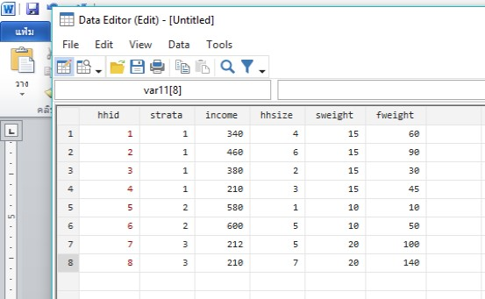

**\*Q1.2:**

* Generating the variable for per capita income *

gen pcinc = income/hhsize

**\*Q1.3:**

* Estimating the average per capita income *

sum pcinc [aw=fweight]



**\*Q1.4:**

*The stata command summarise is not the appropriate command to estimate the standard error of the statistics “mean”. This is because this command does not take into account the sampling design information.*

svyset _n [pweight=sweight], strata(strata)



gen nominator = hhsize*pcinc

gen denominator = hhsize

svy: ratio nominator/denominator



***\* Alternative command (with DASP)***

imean pcinc, hsize(hhsize)



**\*Q1.5**

datest 160, est(78.266670) ste(10.528651)



*- We cannot reject H0: average < 160. This is because the statistical error that we make if we reject H0 is higher than the critical level of 5.00% (the statistical error size is 100.00%).

- We can reject H0: average = 160. This is because the statistical error that we make if we reject H0 is lower than the critical level of 5.00% (the statistical error size is 0.00%).

- We can reject H0: average > 160. This is because that the statistical error that we make if we reject the h0 is lower than the critical level of 5.00% (the statistical error size is 0.00%). *

**\*Q1.6**

*delimit;

dimean pcinc pcinc, hsize1(hhsize) test(100) cond1(strata==3 ) hsize2(hhsize) cond2(strata==1 ) conf(ub)



We can reject H0: difference = > 100. This is because the statistical error that we make if we reject H0 = 3.59 is lower than the critical level of 5.00%.